Lab today pls ignore
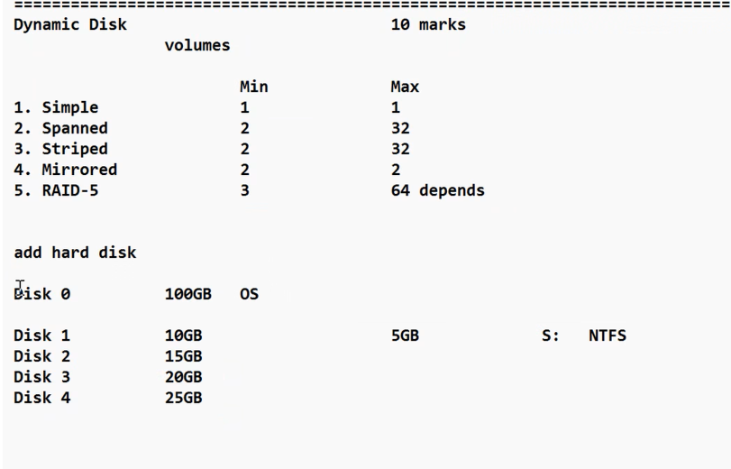
to access data from spanned volume all disk should be online cmplusar of anty one fails we cant access it from any either one…
mkc
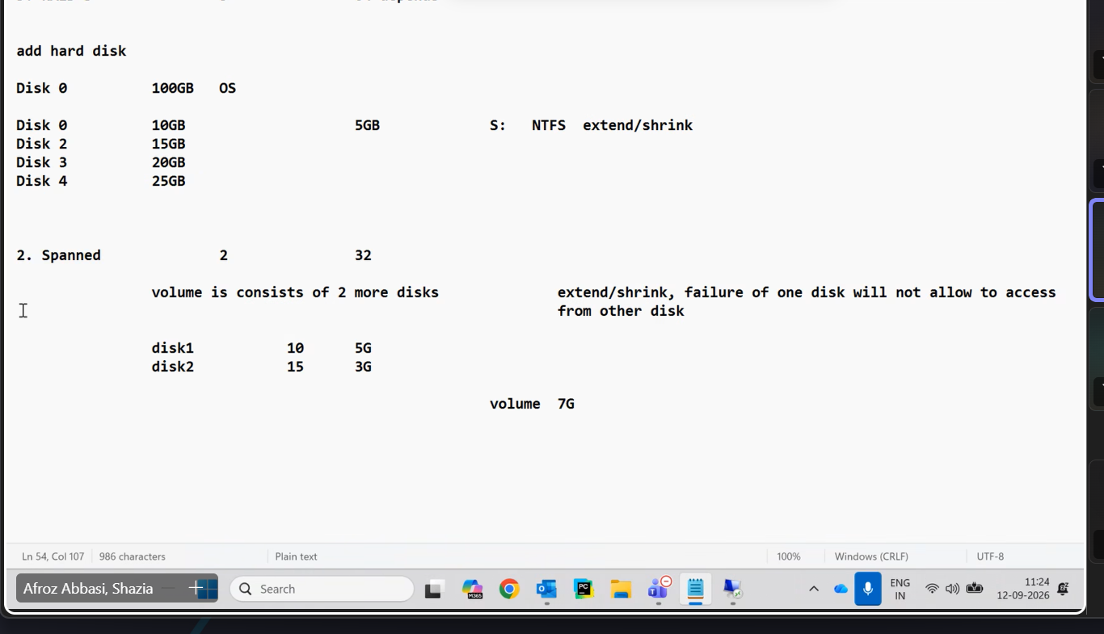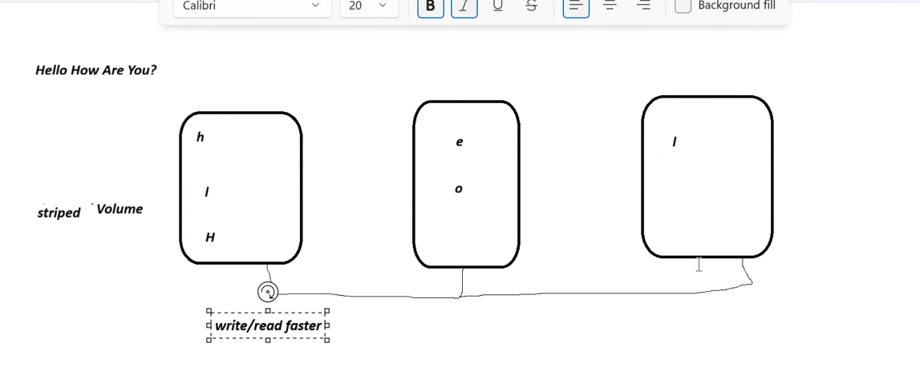
faster :- span < strip as hed of disk is ruunig parallely..
when you want backup of data ..mirriored so fault tolerance failre of one allows other
disdv ..watsge of 50% space ..so wasted adv it can handle the fault
mirror volume bano verufy and fail karke dikhao …it works
only data sync nahi hoga
Right click on disk left panel and reactivate disk after some times it syncs
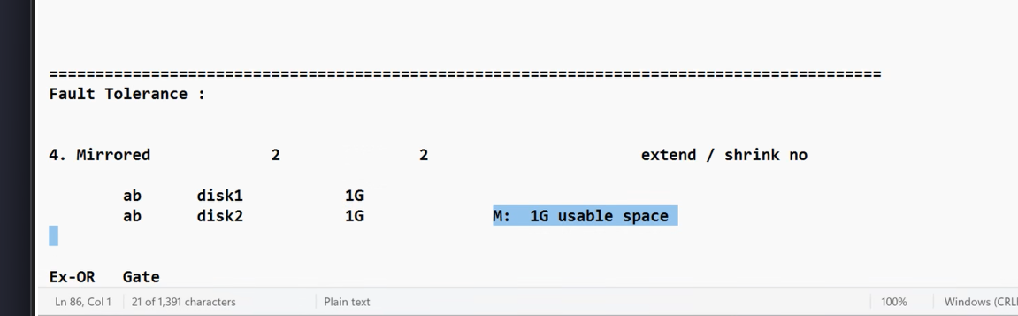
sometimes it doest work so format the right part ..the mirrored ddisk and add foreign disk and next the disk1 hich you took
but mosylt it works
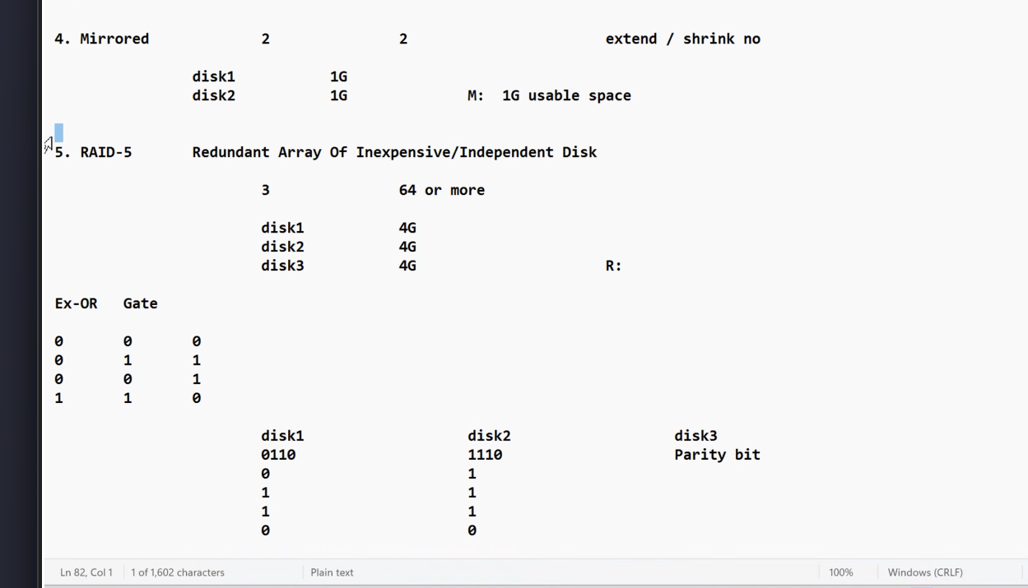
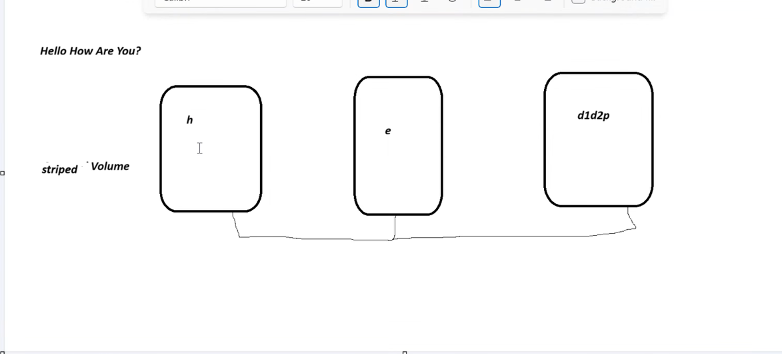raid 5 parity disk google bc
round robin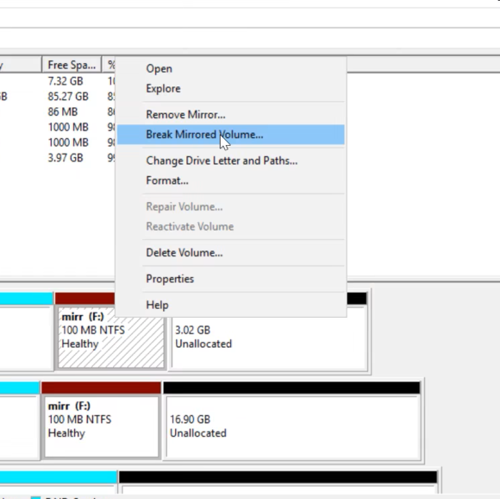
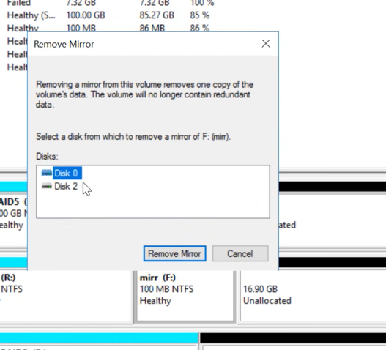
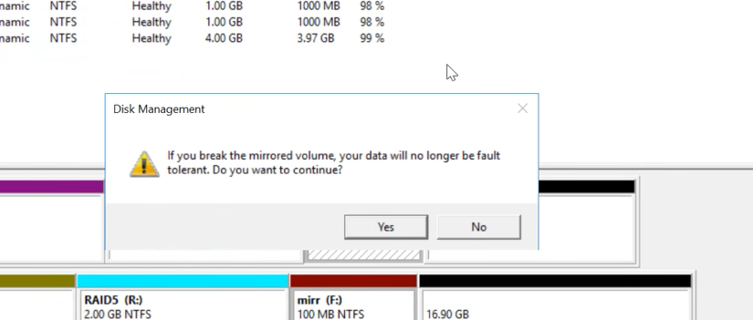
but it wont frmat
b oth will become simple mirrir
this scraetes 2 same copies of both files
Break mirror
both rae independent and no sync between both

